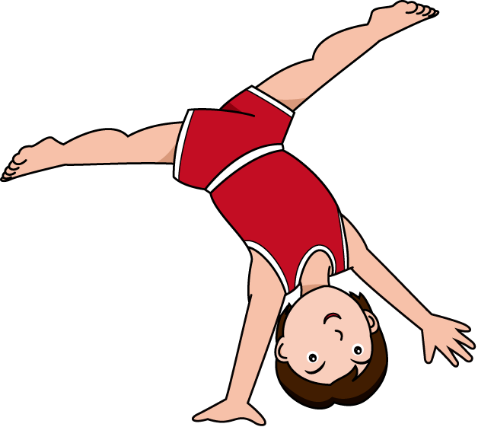

**Sunday February 27th**

**4:00PM – 5:00PM**

Join Genesis Gymnastics for our February

Cartwheel Clinic! We will spend 1 hour working on cartwheels, one-handed cartwheels, and aerials!! Cost is $25!! Sign up today !!

**CARTWHEEL CLINIC!!**